PROJECT REPORT

CAR RENTAL SYSTEM

Abstract: The Car Rental System is a platform that allows clients to rent vehicles from a variety of locations. There are many different types of entities in the system, each with unique properties and connections. Aspects such Vehicle ID, Make, Model, Year, Color, and so on are included in the Vehicle entity. Aspects like Customer ID, Name, Address, Phone Number, and so on are part of the Customer entity. In order to support the platform's functioning, the system also has other entities like Reservation, Rental, Location, Payment, Insurance, Maintenance, Review, and Inventory.

The relationships inside the system explain how the entities communicate with one another. A customer may, for example, make many reservations, each of which is for a single vehicle. In a similar vein, an inventory record links a vehicle to a location, and a rental can have just one insurance option.

Introduction: This report contains the domain description and ER diagram for a car rental system. Vehicle, Customer, Reservation, Rental, Location, Payment, Insurance, Maintenance, Review, and Inventory are just a few of the entities represented in the system. The functionality and requirements of the car rental system are described by a number of attributes and interactions between these entities.

The way these entities interact with one another is critical to the system's operation. A customer may, for example, make many reservations, each of which is for a single vehicle, and each reservation may lead to a rental, and so on. The system's seamless functioning will be guaranteed by a thorough mapping of these relationships.

The Car Rental System will be designed with the domain description and ER diagram as its foundation, with the goal of enhancing rental car administration and offering insightful information about data linkages.

We anticipate a successful project completion that will produce a dependable and efficient system.

ER DIAGRAM:

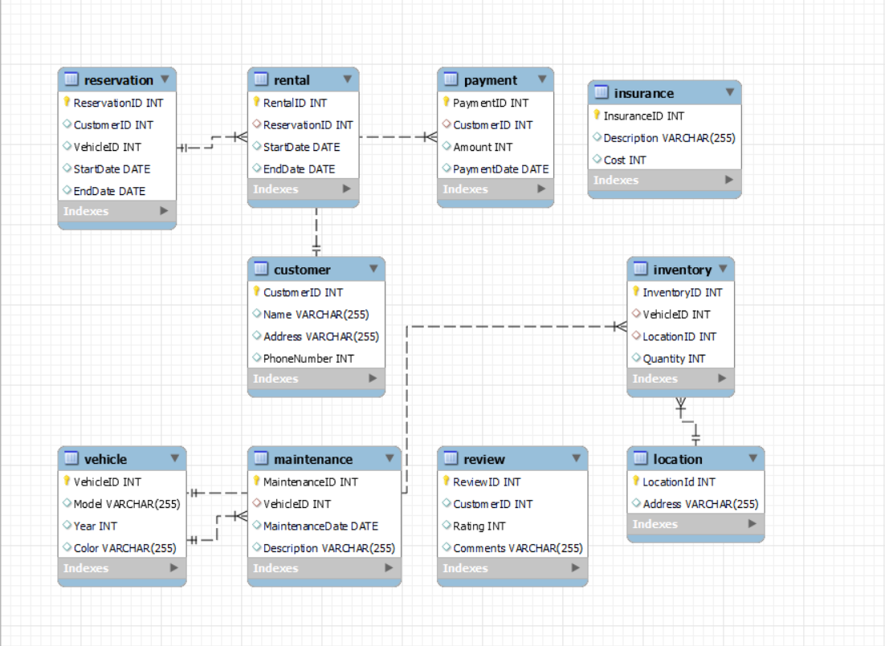

Entities:

1. Vehicle: This represents the cars available for rent. Attributes could include Vehicle ID (Primary Key), Make, Model, Year, Color, etc.

2. Customer: This represents the customers who rent the cars. Attributes could include Customer ID (Primary Key), Name, Address, Phone Number, etc.

3. Reservation: This represents the reservations made by customers. Attributes could include Reservation ID (Primary Key), Customer ID (Foreign Key), Vehicle ID (Foreign Key), StartDate, End Date, etc.

4. Rental: This represents the actual rental of a vehicle. Attributes could include Rental ID (Primary Key), Reservation ID (Foreign Key), StartDate, End Date, etc.

5. Location: This represents the locations where vehicles can be rented from or returned to. Attributes could include Location ID (Primary Key), Address, etc.

6. Payment: This represents the payments made by customers. Attributes could include Payment ID (Primary Key), Customer ID (Foreign Key), Amount, Payment Date, etc.

7. Insurance: This represents the insurance options for the rental. Attributes could include Insurance ID (Primary Key), Description, Cost, etc.

8. Maintenance: This represents the maintenance history of a vehicle. Attributes could include Maintenance ID (Primary Key), Vehicle ID (Foreign Key), Maintenance Date, Description, etc.

9. Review: This represents the reviews given by customers. Attributes could include Review ID (Primary Key), Customer ID (Foreign Key), Rating, Comments, etc.

10. Inventory: This represents the inventory of vehicles at a location. Attributes could include Inventory ID (Primary Key), Vehicle ID (Foreign Key), Location ID (Foreign Key), Quantity, etc.

Relationships:

1. A Customer can make multiple Reservations.

2. A Reservation is for one Vehicle.

3. A Reservation can result in a Rental.

4. A Rental can have one Insurance option.

5. A Rental can have one Payment.

6. A Vehicle can have multiple Maintenance records.

7. A Customer can leave multiple Review.

8. An Inventory record associates a Vehicle with a Location

UML Diagram:

